**CENWP-ODJ8/9/2023**

**MEMORANDUM FOR THE RECORD**

**SUBJECT: *23JDA32 Chinook Morts in Gatewell 1C and 1B***

On Wednesday 9 August 2023, at approximately 0800, JDA fisheries personnel found 1 Chinook subyearling mort in gatewell 1C and 1 Chinook minijack in gatewell 1B. They were removed from the gatewell, scanned for PIT tags (1 had a tag see below) and returned to the river. The morts were several days old. The juvenile subyearling had marks resembling a walleye strike and the minijack was completely descaled on both sides. Personnel will continue to perform daily gatewell inspections to ensure no other mortalities appear.

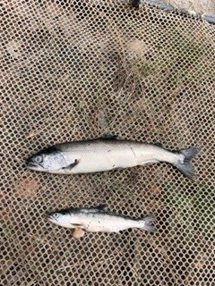

1. Species – Chinook subyearling and minijack
2. Origin – Unclipped
3. Length – Subyearling ~12cm and minijack ~25cm
4. Marks and tags – Chinook minijack PIT Tag -384.0F9986289E
5. Marks and Injuries found on carcass – subyearling walleye strike and minijack descaled.
6. Cause and Time of Death – Presumably from their injuries – time of death unknown.
7. Future and Preventative Measures – Continue performing daily gatewell inspections.

Sincerely,

JDA Project Fisheries